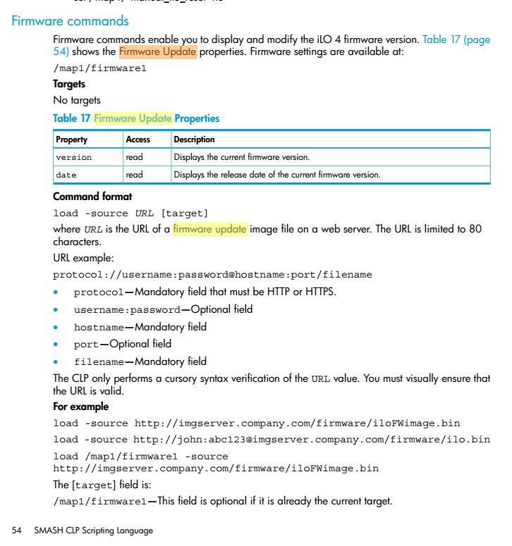
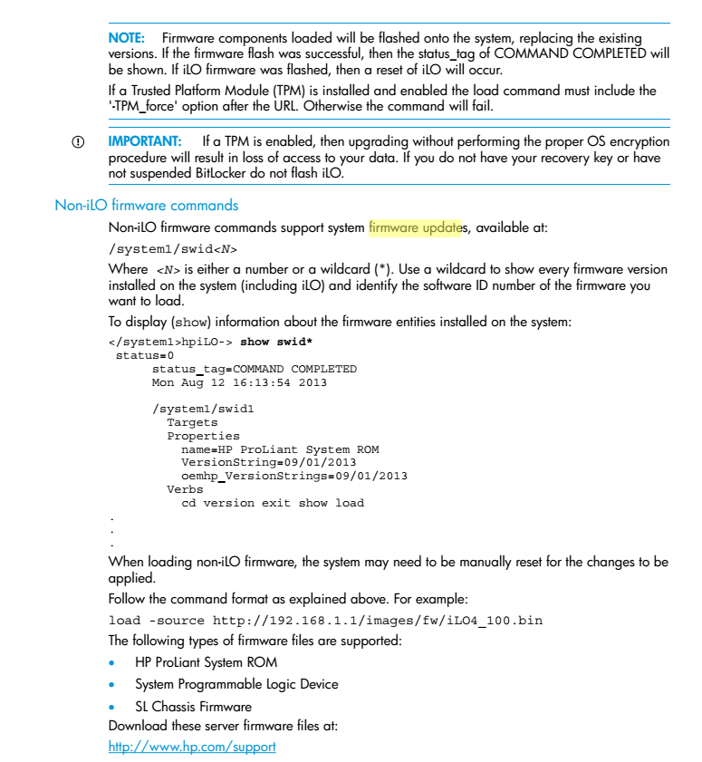
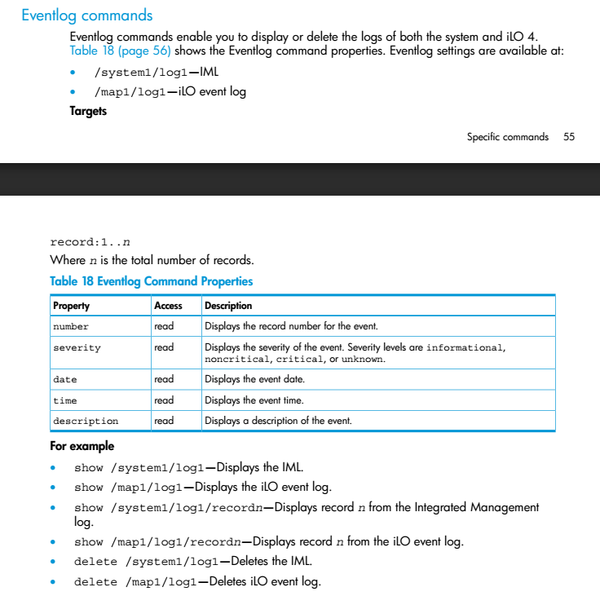

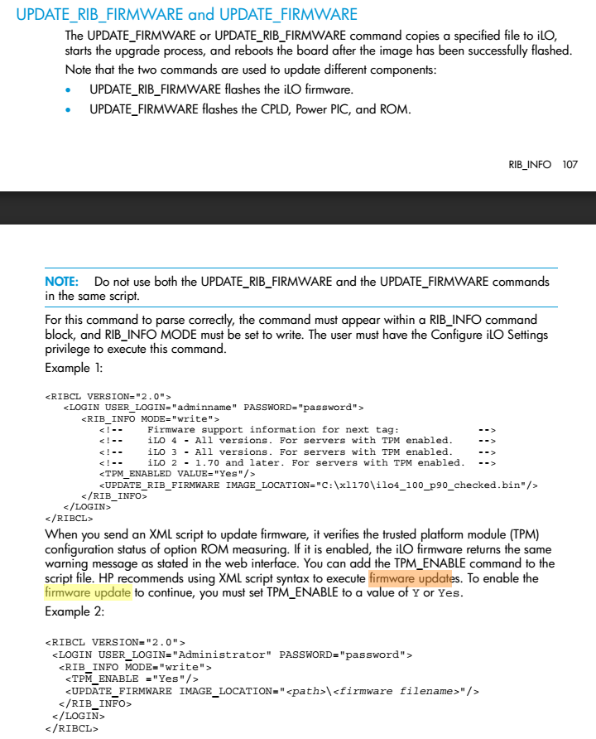

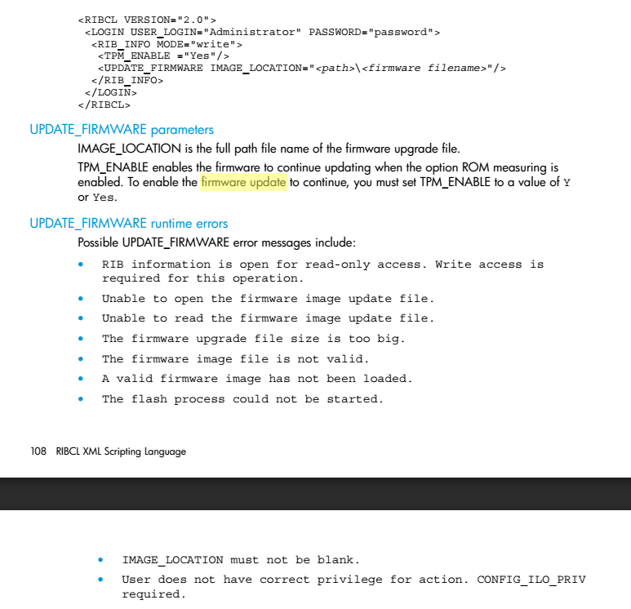

Here is a script that has been used to update iLO version on G7 servers.
$content = Get-Content serverlist.g7.hq-msk-gp-tst.txt
foreach ($line in $content)
{
Write-Host $line
$serveriloname = $line + ".mgmt.tcsbank.ru"
.\HPQLOCFG.exe -s $serveriloname -f .\20141124-1243.hponcfg.ribcl.firmware.upgrade.ilo.xml -u tcsbank\s.belogrud -p $ribclpass
}

This is a file that contain serial numbers of servers.
PS C:\utils\localnet\hpqlocfg> cat serverlist.g7.hq-msk-gp-tst.txt
CZ314824F3
CZ314824F7
CZ31450H69
CZ31450H61
CZ31450H6F
CZ31450H65

PS C:\utils\localnet\hpqlocfg> Set-Variable ribclpass *****

If we want to update on server directly, we can do it if we use this command line.

PS C:\utils\localnet\hpqlocfg> .\HPQLOCFG.exe -s CZ31450H67.mgmt.tcsbank.ru -f .\20141124-1243.hponcfg.ribcl.firmware.upgrade.ilo.xml -u tcsbank\s.belogrud -p $ribclpass

HP Lights-Out Configuration Utility- HPQLOCFG v.1.2.0.0 dated 16/5/2014

(c) Hewlett-Packard Company, 2014

Detecting iLO....
Negotiated cipher:128-bit Aes128 with 160-bit Sha1 and 1024-bit RsaKeyX

Firmware image is being sent ...

Sending image of size:8394340

Sending script...
Waiting for Response...

<?xml version="1.0"?>
<RIBCL VERSION="2.23">
<RESPONSE
STATUS="0x0000"
MESSAGE='No error'
/>
</RIBCL>

<?xml version="1.0"?>
<RIBCL VERSION="2.23">
<RESPONSE
STATUS="0x0000"
MESSAGE='No error'
/>
</RIBCL>
<?xml version="1.0"?>
<RIBCL VERSION="2.23">
<RESPONSE
STATUS="0x0000"
MESSAGE='No error'
/>
</RIBCL>
<?xml version="1.0"?>
<RIBCL VERSION="2.23">
<RESPONSE
STATUS="0x0000"
MESSAGE='No error'
/>

</RIBCL>

<?xml version="1.0"?>
<RIBCL VERSION="2.23">
<RESPONSE
STATUS="0x0000"
MESSAGE='No error'
/>
<INFORM>Firmware flash starting.</INFORM>
</RIBCL>

<?xml version="1.0"?>
<RIBCL VERSION="2.23">
<RESPONSE
STATUS="0x0000"
MESSAGE='No error'
/>
<INFORM>Firmware flash in progress [1%].</INFORM>
</RIBCL>

<?xml version="1.0"?>
<RIBCL VERSION="2.23">
<RESPONSE
STATUS="0x0000"
MESSAGE='No error'
/>
…
<INFORM>Firmware flash in progress [97%].</INFORM>
</RIBCL>

<?xml version="1.0"?>
<RIBCL VERSION="2.23">
<RESPONSE
STATUS="0x0000"
MESSAGE='No error'
/>
<INFORM>Firmware flash in progress [100%].</INFORM>
</RIBCL>
<?xml version="1.0"?>
<RIBCL VERSION="2.23">
<RESPONSE
STATUS="0x0000"
MESSAGE='No error'
/>
<INFORM>Firmware flash completed successfully. iLO 3 reset initiated.</INFORM>
</RIBCL>

Script succeeded for DNS:CZ31450H67.mgmt.tcsbank.ru:443

Here is how it looks on screen into MS Windows Power Shell ISE.

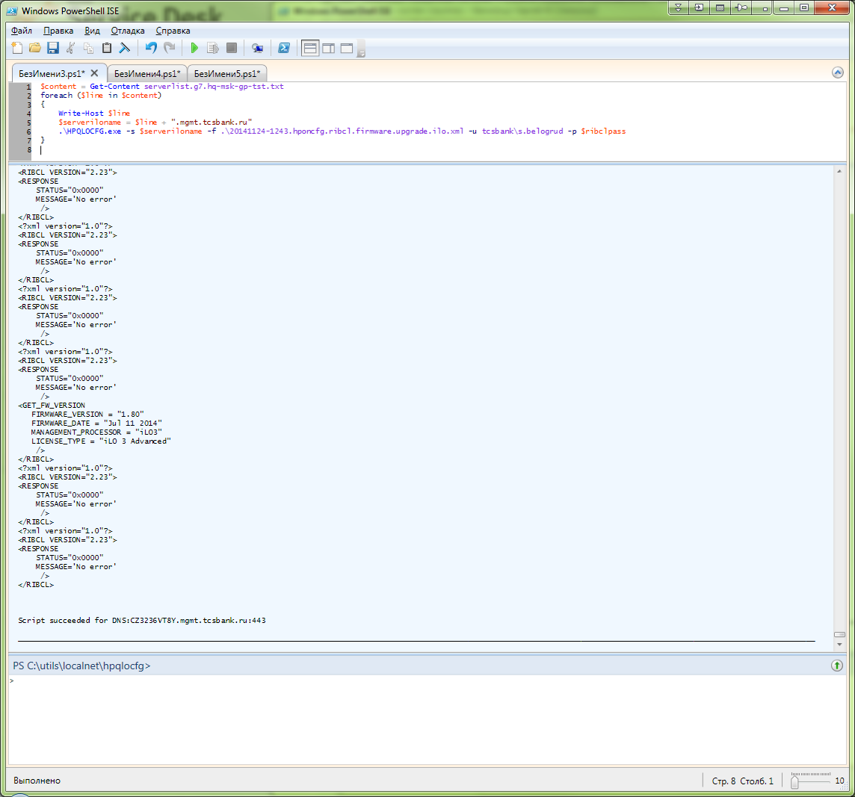

At this picture we can see start of uploading firmware file.

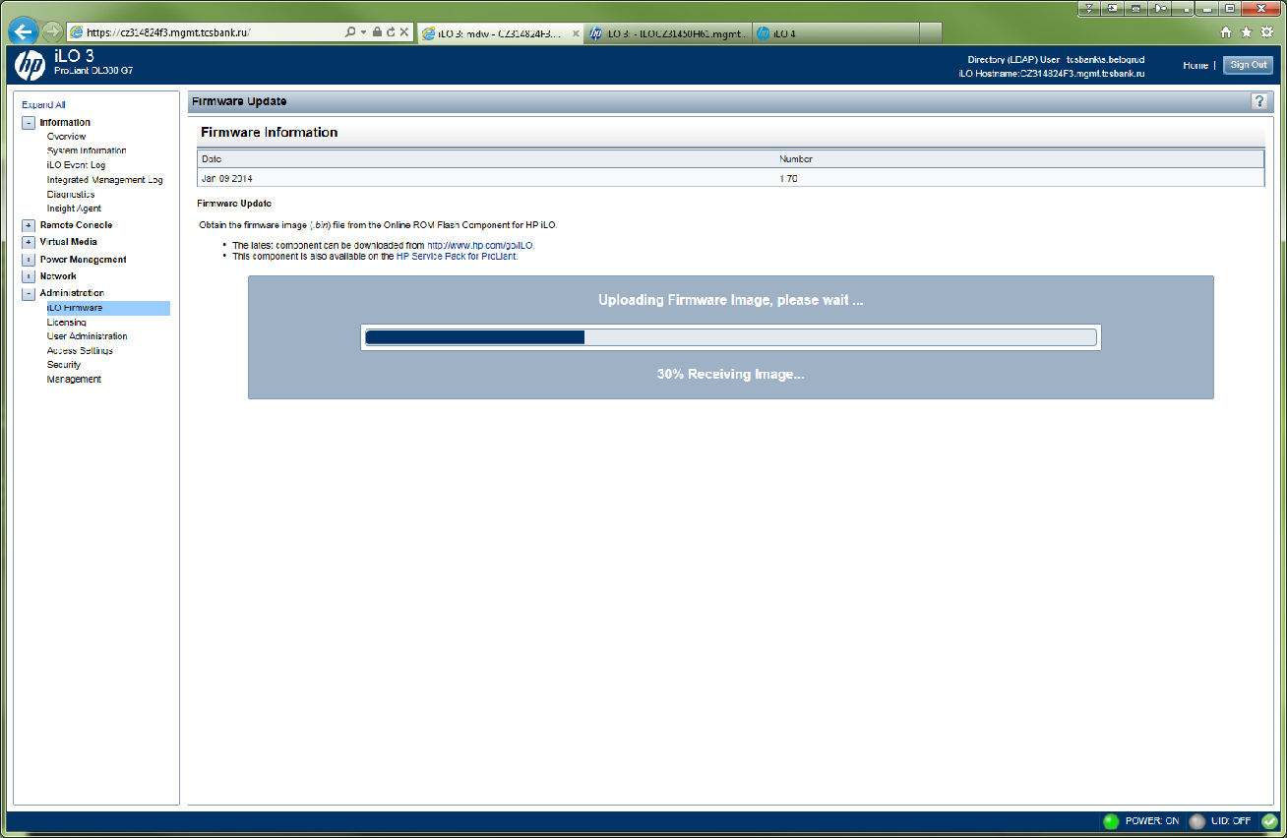

Here is successfully started the process of flashing.
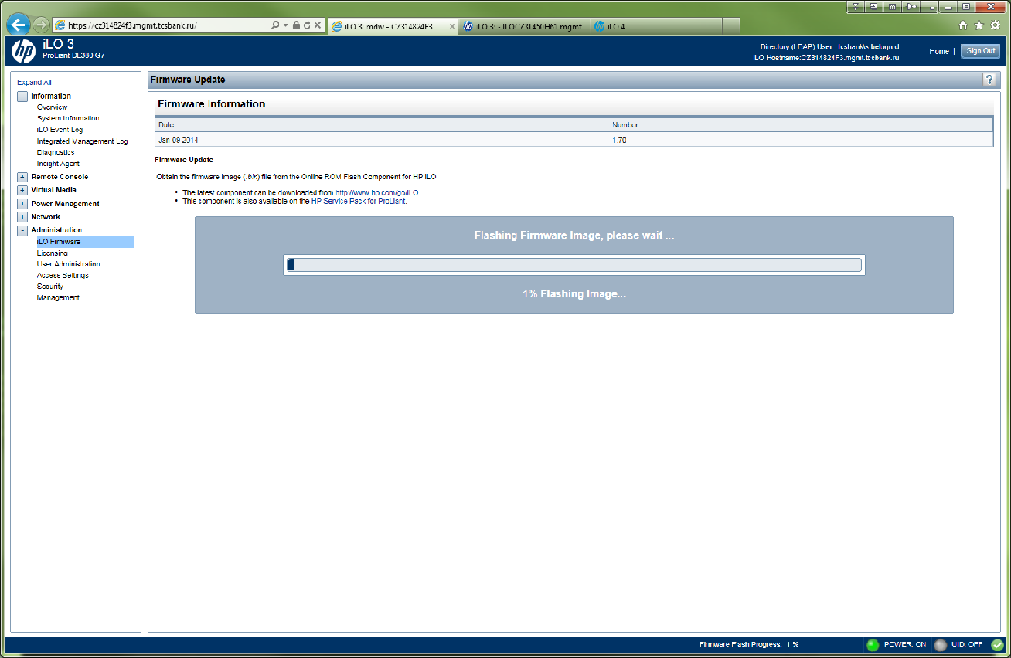

This is same as picture before about uploading firmware.
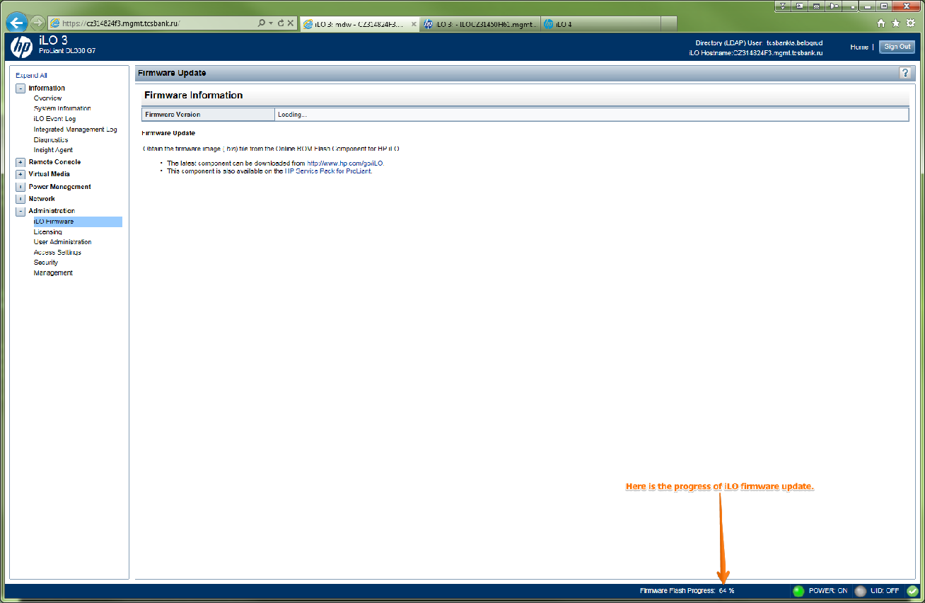

Here we can see a place where is a new version of iLO is desplayed.
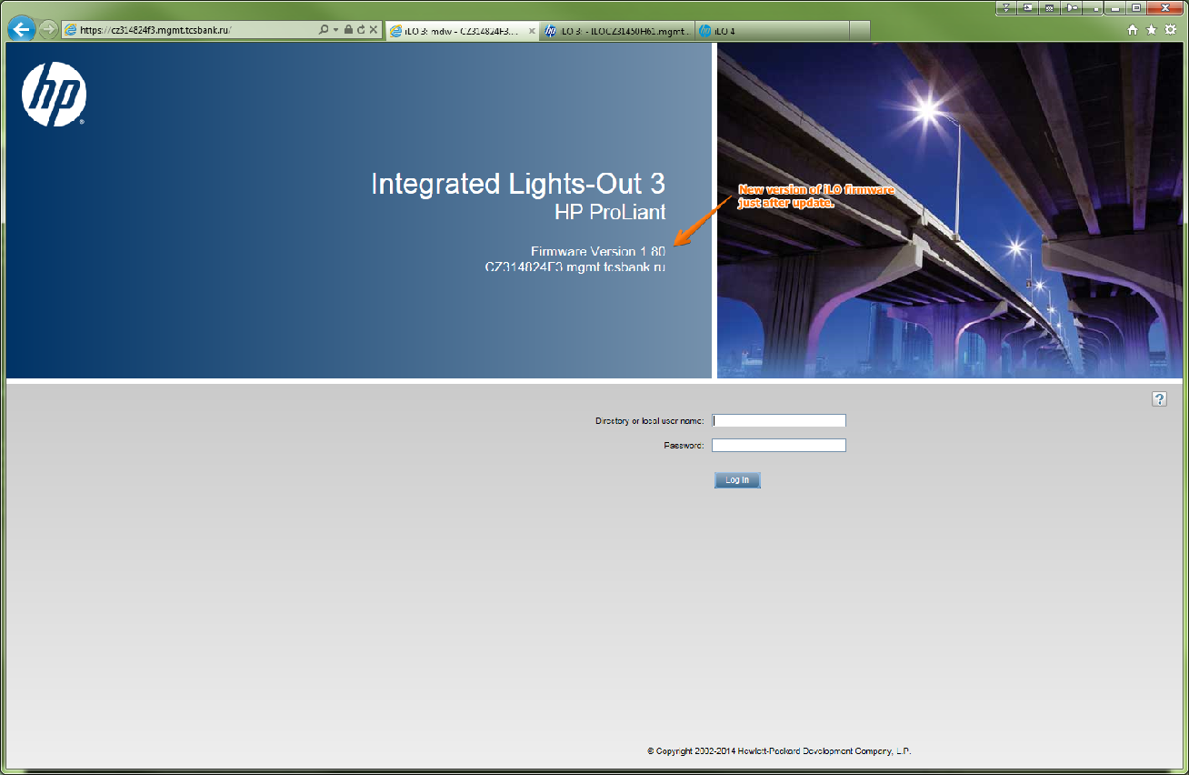

There are messages that show firmware update.
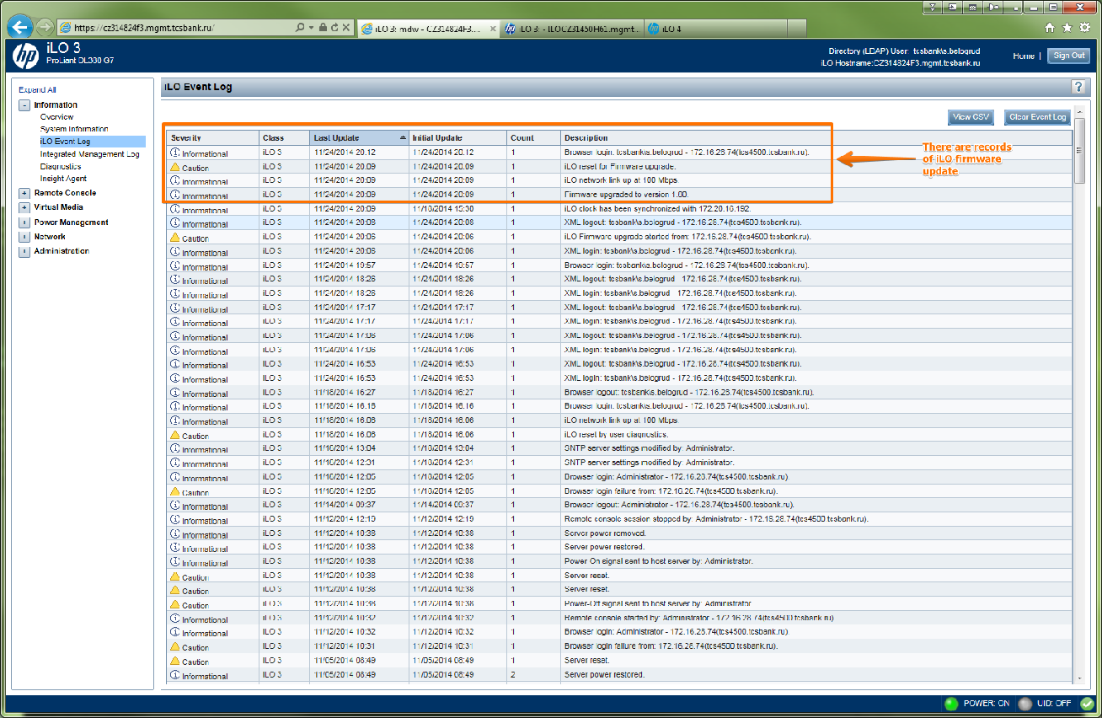

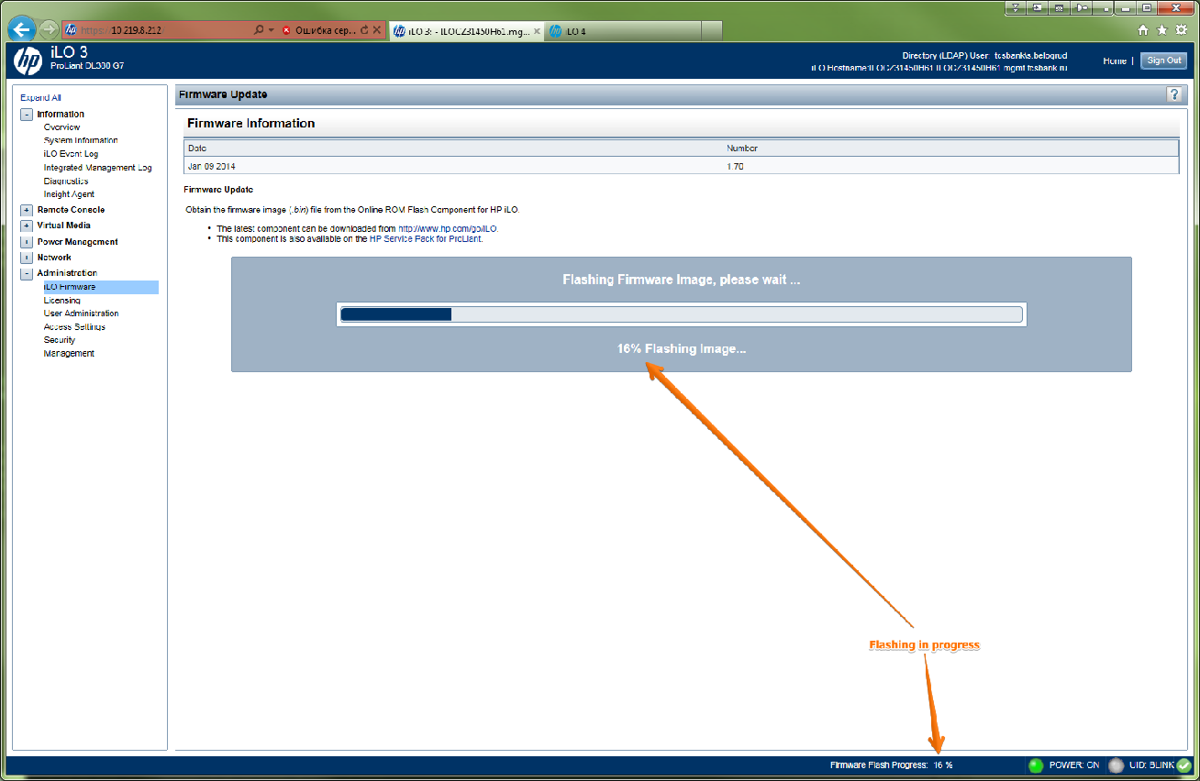

After firmware of iLO was successfully updated, the web-interface of iLO is restarting and connection to it is lost.
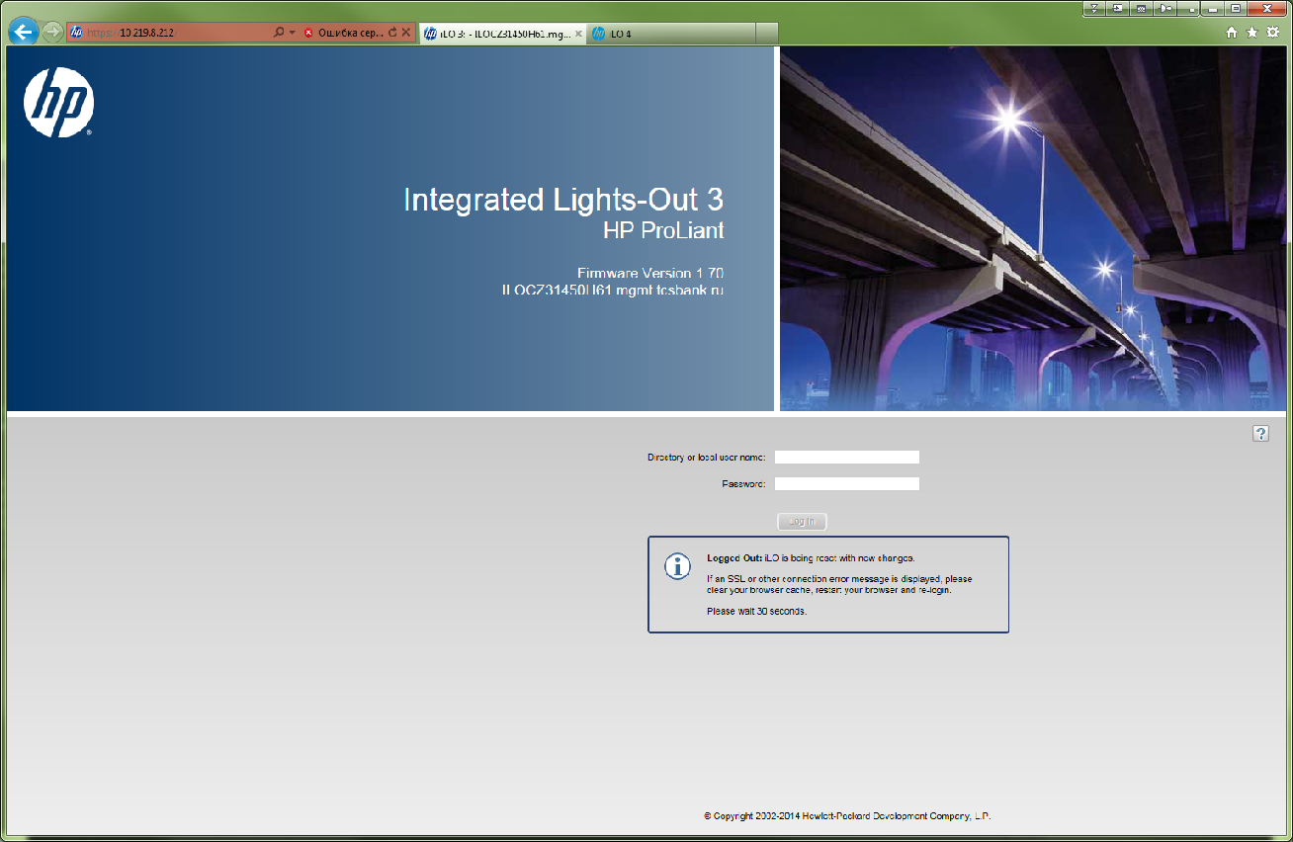

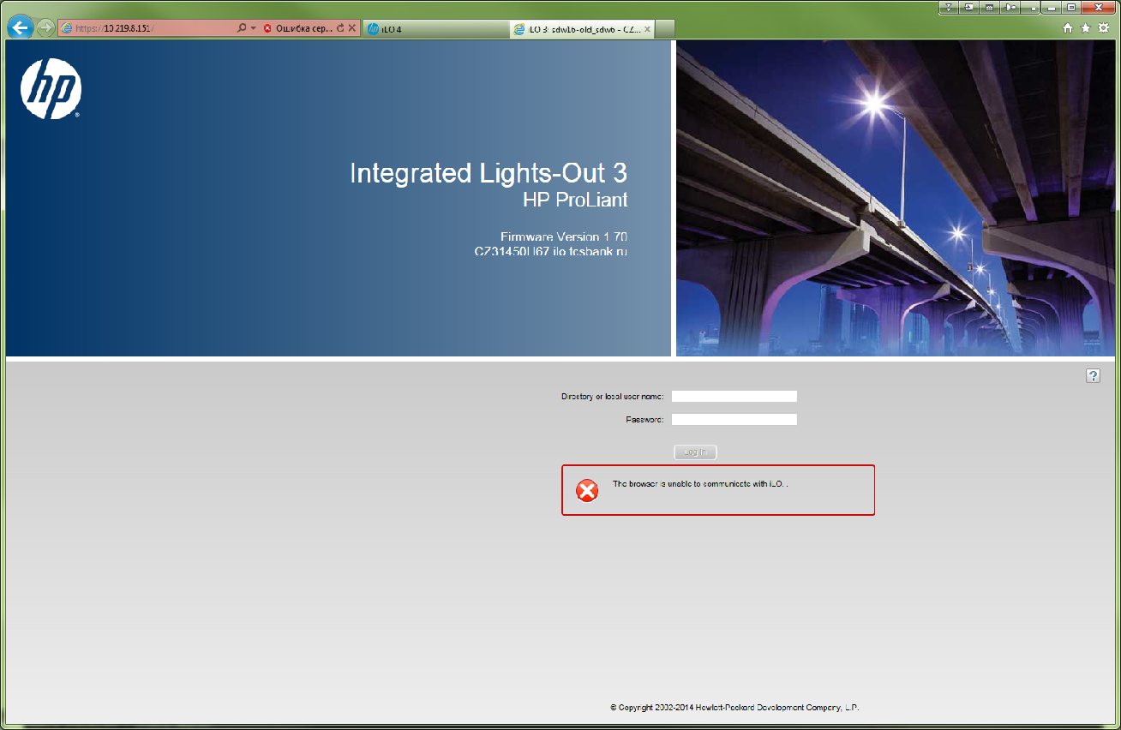

http://h20566.www2.hp.com/hpsc/swd/public/detail?sp4ts.oid=4154847&swItemId=MTX_60584a6af22849f49a0cee6506&swEnvOid=4103#tab3

Firmware CD Supplemental Update / Online ROM Flash Component for Linux - HP Integrated Lights-Out 3
By downloading, you agree to the terms and conditions of the HP Software License Agreement.
Note: Some software requires a valid warranty, current HP support contract, or a license fee.
Type: Firmware - Lights-Out Management
Version: 1.80(9 Sep 2014)
Operating System(s): Red Hat Enterprise Linux 6 Server (x86-64) | View all

File name: CP022551.scexe (6.9 MB)
• DescriptionThis is a tab. Use the arrow keys to navigate through the tabs.
• EnhancementsThis is a tab. Use the arrow keys to navigate through the tabs.
• Installation InstructionsThis is a tab. Use the arrow keys to navigate through the tabs.
• Release NotesThis is a tab. Use the arrow keys to navigate through the tabs.
• FixesThis is a tab. Use the arrow keys to navigate through the tabs.
• ImportantThis is a tab. Use the arrow keys to navigate through the tabs.
• Revision HistoryThis is a tab. Use the arrow keys to navigate through the tabs.
Prerequisites:
Customers running a version of iLO 3 previous to v1.20 must upgrade v1.20 before upgrading to this version. iLO 3 v1.20 may be obtained from the following FTP locations:

Linux: ftp://ftp.hp.com/pub/softlib2/software1/sc-linux-fw-ilo/p1255562964/v64722
Windows: ftp://ftp.hp.com/pub/softlib2/software1/sc-windows-fw-ilo/p901462262/v64721
Win64: ftp://ftp.hp.com/pub/softlib2/software1/sc-windows-fw-ilo/p1728391553/v64720
________________________________________
To ensure the integrity of your download, HP recommends verifying your results with this MD5 Checksum value:
ea7b05a8f7809204cd03710d36cce6b5 CP022551.scexe
Reboot Requirement:
Reboot is optional after installation. Updates will be effective after reboot. Hardware stability will be maintained without reboot.
________________________________________
Installation:
Update via Online Linux Environment:
To update firmware from the Linux operating system on target server:
1. Download the SCEXE file to the target server.
2. Run: sh CP022551.scexe
Update via iLO GUI, Utilities, or Scripting Interface:
To obtain firmware image for updating via iLO user interface, utilities, or scripting interface:
1. Download the SCEXE file to a client running a Linux operating system.
2. Run: sh CP022551.scexe --unpack=directory.
This command will unpack the iLO3 bin into a user specified "directory". If the directory does not exist, the unpacker will attempt to create it.
Update via HP Support Pack for ProLiant:
To use HP Smart Update Manager (HP SUM) from the HP Service Pack for ProLiant (SPP):

Offline:
1. Place the HP Service Pack for ProLiant on a USB key using the HP USB Key Creator Utility.
2. Place the desired firmware to be updated in the directory, /SPP20xxxxx/hp/swpackages on the USB key.
3. Boot from the newly created HP Service Pack for ProLiant USB key.
4. Follow HP Smart Update Manager steps to complete firmware update.
NOTE: Use Offline mode to update systems running VMware ESXi 4.0 or ESXi 4.1.

Online:
1. Login as root. (You must be root in order to apply the ROM update.)
2. Place the desired firmware to be updated in the directory, /SPP20xxxxx/hp/swpackages.
3. Locate Start.html which is found in the root of the ISO.
4. Open the html file in a supported browser.
5. Follow the instructions on the screen to complete the firmware update.

